VISVESVARAYA TECHNOLOGICAL UNIVERSITY BELAGAVI – 590018

A Project Report on
“DENTRAZE: Digital Dental Imaging and Cephalometric Landmark Platform”
Submitted in partial fulfillment of the requirements for the degree of BACHELOR OF ENGINEERING
IN
INFORMATION SCIENCE AND ENGINEERING Subject: PROJECT PHASE II [BIS786]

Submitted By

Aayush Shetty Ayush  Gaurav T Sanil  Harthik S Poonja | 4JK22IS001  4JK22IS009  4JK22IS024  4JK22IS025

Under the guidance of
Prof. Arpitha Kumari G Assistant Professor Dept. of ISE


DEPARTMENT OF INFORMATION SCIENCE AND ENGINEERING
Accredited by NAAC and NBA (BE: CV, CSE, ECE, ISE & ME)
A. J. INSTITUTE OF ENGINEERING & TECHNOLOGY
A unit of Laxmi Memorial Education Trust®
(Approved by AICTE, New Delhi, affiliated to VTU, Belagavi, Recognized by Govt. of Karnataka)
NH-66, KOTTARA CHOWKI, MANGALURU – 575006 2024 - 2025

A. J. INSTITUTE OF ENGINNERING & TECHNOLOGY
NH – 66, Kottara Chowki, Mangaluru - 575006
A Unit of Laxmi Memorial Education Trust (R)
(Affiliated to Visvesvaraya Technological University, Belagavi & Approved by AICTE, New Delhi)
Accredited by NAAC and NBA (BE: CV, CSE, ECE, ISE & ME)

DEPARTMENT OF INFORMATION SCIENCE AND ENGINEERING

CERTIFICATE

Certified that the project work entitled “DENTRAZE: Digital Dental Imaging and Cephalometric Landmark Platform” carried out by AAYUSH SHETTY (4JK22IS001), AYUSH (4JK22IS009), GAURAV T SANIL (4JK22IS024) and HARTHIK S POONJA
(4JK22IS025) a bonafide student of A.J. Institute of Engineering & Technology, Mangaluru, in partial fulfillment for the award of Bachelor of Engineering in Information Science and Engineering of Visveswaraya Technological University, Belagavi during the year 2024- 2025. It is certified that all corrections/suggestions indicated for Internal Assessment have been incorporated in the Report deposited in the departmental library.
The project report has been approved as it satisfies the academic requirements in respect of Project Work prescribed for the said Degree.

Prof. Arpitha Kumari G  Project Guide | Prof. Rakesh M R  Project Coordinator | Dr. John Prakash Veigas  Head of the Department
Dr. Shantharama Rai C
Principal

Examiners | Signature with Date

1.
2.

ACKNOWLEDGEMENT
The joy and satisfaction that accompany the successful completion of any task would be incomplete without the mention of the people who made it possible.
We would like to express our gratitude to our Principal, Dr. Shantharama Rai C for providing us a congenial environment for engineering studies and also for having need to us the way to carry out the project.
We consider it a privilege to express our sincere thanks to Dr. P. Mahabaleswarappa, Dean of Academics, for his invaluable support and encouragement throughout the course of this project.
We consider it a privilege to express our sincere thanks Dr. John Prakash Veigas, Professor and Head, Department of Information Science and Engineering for his support and valuable guidance throughout the tenure of this project.
We would like to thank our Guide Prof. Arpitha Kumari G, Assistant Professor, Department of Information Science and Engineering for her support, guidance, motivation, encouragement for the successful completion of this project.
We would like to thank our Project Coordinator Prof. Rakesh M R, Assistant Professor, Department of Information Science and Engineering for his support, guidance, motivation, for useful tips and timely suggestions for the successful completion of this project.
We intend to thank all the teaching and non-teaching staffs of our Department of Information Science and Engineering for their immense help and co-operation.
Finally, we would like to express our gratitude to our parents and friends who always stood by us

Aayush Shetty Ayush
Gaurav T Sanil Harthik S Poonja

DECLARATION
We Aayush Shetty, Ayush, Gaurav T Sanil and Harthik S Poonja hereby declare that this dissertation work titled “DENTRAZE: Digital Dental Imaging and Cephalometric Landmark Platform” has been carried out independently by us under the guidance of Prof. Arpitha Kumari G, Assistant Professor, Department of Information Science and Engineering, AJIET, Mangaluru in partial fulfillment of the requirement of the degree BACHELOR OF ENGINEERING in Information Science and Engineering under VTU Belagavi.
We further declare that we have not submitted this dissertation either in part or full to any other university for the award of any degree

Place: Mangaluru Date: | Aayush Shetty Ayush  Gaurav T Sanil  Harthik S Poonja

ABSTRACT

Dentists have traditionally examined X-rays and marked cephalometric points manually a process that is slow, inconsistent, and prone to error. To address this, we developed DENTRAZE, an AI-powered platform designed to streamline routine dental diagnostics. The system integrates advanced deep-learning models such as YOLOv8 for fast tooth detection, U-Net with a ResNet backbone for cephalometric landmark extraction, and YOLOv8X-Seg for cavity and metal implant identification. These models are trained on diverse datasets sourced from Roboflow and Kaggle, supported by extensive preprocessing to handle real world variations in dental imaging. During testing, DENTRAZE demonstrated reliable tooth detection, precise landmark mapping, and accurate cavity segmentation—significantly reducing diagnostic time and minimizing human error. By combining advanced AI with a clean and intuitive interface, DENTRAZE enhances clinical efficiency and improves communication between dentists and patients.

Keywords: — Dental AI, YOLOv8, U-Net, ResNet, Cephalometric Analysis, Automated Diagnostics, Tooth Detection.

TABLE OF CONTENTS

CHAPTERS | TITLE | PAGE NO
 | ACKNOWLEDGEMENT | i
 | DECLARATION | ii
 | ABSTRACT | iii
 | LIST OF FIGURES | vi
CHAPTER 1 | INTRODUCTION | 1 – 10
1.1 | Chapter Overview | 1
1.2 | Introduction | 1
1.3 | Motivation | 2
1.4 | Problem Statement | 3
1.5 | Objective | 3
1.6 | Project Methodology | 4
1.7 | Questioning | 5
1.8 | Organization of Report | 6
1.9 | Chapter Summary | 7
CHAPTER 2 | LITERATURE SURVEY | 11 – 16
2.1 | Chapter Overview | 8
2.2 | Related Works | 9
2.3 | Chapter Summary | 10
CHAPTER 3 | GROUND SURVEY | 17 – 19
3.1 | Chapter Overview | 11
3.2 | Suggestions | 11
3.3 | Chapter Summary | 14
CHAPTER 4 | REQUIREMENT SPECIFICATION | 20 –22
4.1 | Chapter Overview | 15
4.2 | Specification Requirements | 15
4.3 | Project Environment Setup | 16
4.4 | System Analysis | 18
4.5 | Chapter Summery | 19
CHAPTER 5 | SYSTEM DESIGN | 23 – 29
5.1 | Chapter Overview | 20
5.2 | System Architecture | 20
5.3 | Module Description | 22
5.4 | Methodology flow diagram | 24
5.5 | Chapter Summary | 26
CHAPTER 6 | IMPLEMENTATION | 30 – 35
6.1 | Chapter Overview | 27
6.2 | Implementation steps | 27
6.3 | Chapter Summary | 32
CHAPTER 7 | RESULT DISCUSSION | 36 – 39
7.1  7.2 | Chapter Overview  Result | 33  33
7.3 | Result Discussion | 34
7.4 | Chapter Summary | 36
CHAPTER 8 | CONCLUSION AND FUTURE ENHANCEMENT | 40 – 41
8.1 | Learnings | 40
8.2 | Conclusion | 40
8.3 | Future Enhancement | 41
 | REFERENCES

LIST OF FIGURES

FIGURE NO. | DESCRIPTION | PAGE NO
3.1  5.1 | Discussion on Diagnostic Workflow  System Architecture Description | 18  24
5.2 | Dataflow Diagram | 26
5.3 | Methodology Flow Diagram | 28
6.1 | Cephalometric Benchmark Datasets | 31
6.2 | Tooth annotation Datasets | 31
6.3  6.4  6.5  6.6  6.7  6.8  6.9  6.10 | metal and object detection  code snippet of registration page  code snippet of login page  code snippet of login page  code snippet of FDI numbering  code snippet for model architecture  code snippet for cavity detection  code snippet for cephalometric model training script | 31  32  33  33  34  35  36  37
7.1 | Training and Validation Accuracy | 40

CHAPTER 1

INTRODUCTION

Chapter Overview
This chapter serves as a foundational introduction to the DENTRAZE platform, a digital solution designed to enhance dental diagnostics through automated imaging and cephalometric landmark identification. It outlines the significance of the project in the context of modern dentistry, the motivation driving its development, the specific challenges it aims to address, and the objectives that guide its implementation. By providing a comprehensive overview, this chapter sets the stage for understanding the subsequent sections of the report, which delve into the literature survey, requirement specifications, system design, implementation, results, and future enhancements. It emphasizes the potential of AI to transform traditional dental practices by improving accuracy and efficiency. This introduction also highlights the collaborative role of clinicians and technology in advancing personalized patient care.

Introduction
Dentistry, like many medical fields, is rapidly moving toward digital automation. Although imaging technologies such as intraoral and panoramic radiographs have improved, dental diagnosis still depends heavily on manual interpretation, which is time-consuming, labor-intensive, and varies across practitioners. Tasks such as tooth numbering, cavity detection, metal restoration identification, and cephalometric analysis are still performed manually, often leading to inconsistencies and diagnostic delays. Recent advances in artificial intelligence and deep learning (DL) have shown strong results in medical imaging, especially in radiology and ophthalmology. The dental field offers similar potential, where automated systems can enhance precision, consistency, and efficiency in analyzing radiographic images. DENTRAZE aims to bridge this gap by offering an integrated AI-driven dental diagnostics platform. It uses YOLOv8l-Seg for FDI tooth detection, YOLOv8x-Seg for cavity and metal implant identification, and a U-Net model with a ResNet backbone for cephalometric landmark detection, additional post processing to draw planes and calculate the angle between the intersection of the planes for required analysis.

Motivation

Social Impact
      - The AI models used in DENTRAZE are trained on diverse datasets to ensure high accuracy across different age groups, dental conditions, and image qualities.
      - It facilitates remote diagnostics, allowing dentists to review AI-analyzed results and X- rays from anywhere, promoting tele-diagnostic capabilities.
      - By integrating with existing dental imaging equipment, DENTRAZE ensures easy adoption without the need for new hardware investment.
      - The platform supports multilingual interfaces and customizable analysis reports, making it suitable for global deployment.
      - DENTRAZE can prioritize severe cases in patient queues by automatically flagging critical conditions like impacted teeth or advanced caries.
      - Real-time feedback during image uploads helps ensure radiographs are of sufficient quality before analysis begins, reducing rescan rates.
      - The AI continually improves with user feedback, adapting to new patterns and enhancing accuracy over time through continuous learning.
      - It streamlines clinic workflows by auto-generating diagnostic summaries and chart annotations, saving valuable time for practitioners.
      - DENTRAZE offers role-based access control, ensuring that patient data and diagnostic tools are securely accessed by authorized users only.
      - It promotes preventive dentistry by highlighting patterns and trends in patient records, helping clinicians offer proactive care suggestions.

Economic Impact
      - From an economic standpoint, DENTRAZE helps optimize clinic resources by automating diagnostic procedures that would otherwise require time-consuming manual analysis. Tasks such as identifying teeth numbers, marking anatomical landmarks, and detecting cavities can be handled efficiently, saving time for both practitioners and patients.
      - By accelerating the diagnostic process and improving accuracy, the platform reduces the chances of misdiagnosis and unnecessary treatments, which can result in cost savings for both clinics and patients. Early detection enabled by AI tools also helps in avoiding complex and expensive procedures that arise from delayed treatment.

      - DENTRAZE can be integrated into orthodontics laboratories and dental hospitals, enabling mass screening with minimal professional oversight. This reduces the operational burden on healthcare workers and improves outreach efforts.
      - The system can serve as a scalable solution for multi-location dental chains, reducing the need for highly specialized diagnostic staff at every branch. AI-driven diagnostics ensure that all patients receive high-quality assessments, regardless of location, leading to uniformity in service delivery.

Problem Statement
Dental diagnostics, especially in areas like analyzing X-rays and detecting cavities, are crucial for effective treatment. However, current methods, such as manual charting and basic imaging, often lead to errors, delays, and inconsistent results. For example, cephalometric analysis, which is important for orthodontic treatment planning, is time- consuming and can be prone to mistakes. Similarly, detecting cavities and metal objects can be inaccurate with existing tools, which may lead to missed diagnoses or incorrect treatments. These challenges, combined with the manual effort required for dental charting, slow down the process and increase the risk of human error. Moreover, current solutions lack the use of advanced technologies like AI, which could automate and improve the diagnostic process. There is a clear need for a better solution that can provide faster, more accurate, and reliable results. The DENTRAZE platform addresses this need by using AI to automate dental notation, improve cephalometric analysis, detect cavities more accurately, and streamline digital charting, ultimately enhancing the efficiency and quality of dental care.

Objective
- Develop an Useful dental diagnostic platform: To create a system that automates dental tasks like dental notation, cephalometric analysis and cavity detection. This will reduce manual work, minimize errors, and speed up the diagnostic process.
- Enhance accuracy in cephalometric analysis: To use AI to improve the precision of measuring dental and skeletal structures from X-ray images, making orthodontic treatment planning more reliable and efficient.
- Automate cavity and metal object detection: To implement deep learning algorithms that can automatically identify cavities and metal objects in dental images.

- Streamline dental charting: To develop a digital charting system that automates the creation and management of patient records, making the process faster, more organized, and less prone to errors.
- Improve overall patient care: To help dental professionals provide faster, more accurate diagnoses, leading to better treatment outcomes and a higher level of patient satisfaction.

Methodology

Requirement Analysis
Objective: The goal was to automate and enhance the dental diagnostic process, improving both accuracy and efficiency. Several challenges in the dental diagnostic workflow were identified through expert consultations and research:
  - Reducing the manual effort involved in identifying and labeling dental features.
  - Improving the accuracy of cephalometric analysis.
  - Detecting dental cavities, metal objects (such as crowns and braces).

Data Collection and Preprocessing Data Collection:
  - Dental X-rays: Collected panoramic X-rays from open- source datasets and clinical partners.
  - Cephalometric Images: Annotated cephalometric X-rays with specific landmark points for model training.
  - Metal Object Detection: Sourced images containing dental restorations like braces, implants, and crowns.

Preprocessing:

  - Annotations : Annotating the collected datasets using roboflow.
  - Normalization: All images were normalized to a fixed range (0-1) to prepare for model input.
  - Resizing: Images were resized to a uniform dimension, typically 768×768 and 512×512 pixels, ensuring consistency.
  - Noise Reduction: Filtering techniques were used to remove background noise from the X-ray images.
  - Data Augmentation: Applied rotation, image enhancement and zooming techniques to enhance model generalization and robustness.

Model Development Cephalometric Analysis:
  - Model: A U-Net with a ResNet backbone was employed to predict cephalometric landmarks in X-ray images, ensuring high spatial accuracy.
  - Purpose: To accurately locate and generate the hotspots on the detected keypoints.

Cavity and Metal Object Detection:

Model: YOLOv8x-Seg was used for detecting cavities, metal restorations, and crowded regions in dental X-rays.
Purpose: This real-time segmentation model was trained to identify cavities, crowns, metal implants, and restoration areas with high precision.

Dental Notation:
  - Model: YOLOv8l-Seg, a segmentation-based detector, was used to recognize and label individual teeth according to the FDI (Fédération Dentaire Internationale) notation system.

Model Training:

  - Using some open code editors like colab, VScode.
  - Using some random augmentations initializing proper batch size and early stopping techniques.
  - Training Environment: Ultralytics and PyTorch frameworks were used to develop and train the models, leveraging GPU acceleration for faster processing .

System Design and Integration Modular Architecture:
  - The system was designed with a modular approach to ensure that each AI model (cephalometric analysis, cavity detection, dental notation) could be independently deployed and scaled.
  - The AI modules were integrated into a unified platform, allowing for seamless interaction and data flow between components.

User Interface:
  - A web-based user interface was developed, allowing dental professionals to upload X-ray images and view the analysis results in real-time.
  - Frontend: Developed using HTML, CSS, and JavaScript to create a responsive and user-friendly design.

  - Backend: The backend was developed using Python, with Flask as the web framework to handle requests, while the AI models were executed using OpenCV, NumPy, Pillow, Ultralytics, Matplotlib, PyTorch for efficient image processing, model importing, angle predictions, visualization.

Testing and Evaluation Unit Testing:
  - Each module (cephalometric analysis, cavity detection, dental notation) underwent unit testing to ensure the correctness of individual features.

System-Level Testing:

  - After integrating all modules, system-level testing was conducted using real-world dental images. This helped ensure that all modules worked together seamlessly.
  - Metrics: Precision, recall, F1 score, and PCK were used to evaluate the performance of the platform.

Evaluation Metrics:

  - For Cephalometric Analysis: Mean Squared Error (MSE) and Normalized Mean Error (NME) were used to measure the accuracy of landmark detection.
  - For Object Detection: Intersection over Union (IoU) was employed to evaluate the accuracy of cavity and metal object detection.
  - For Classification: Accuracy and F1 scores were calculated to assess the performance of the dental notation models.

User Feedback:

  - The platform was tested in a simulated clinical environment with real dental professionals. Feedback was collected to identify areas for improvement in usability, interface design, and model performance.

Deployment and Finalization Deployment:
  - The platform was deployed in a simulated clinical environment for real-time testing to ensure its functionality and gather feedback from actual users.

System Optimization:

  - System performance was optimized for fast processing of high-resolution images, ensuring quick and accurate results. The platform was tested in a simulated clinical environment with real dental professionals.

Questioning
- How accurately can the DENTRAZE platform classify dental structures from X-ray images?
This question focuses on the performance of the AI models integrated into DENTRAZE, specifically assessing their accuracy in detecting and classifying various dental structures, such as teeth, cavities, and metal restorations.Metrics to evaluate include accuracy, precision, recall, and F1-score, which will provide a comprehensive understanding of the model's classification capabilities.
- Can the platform effectively automate the diagnostic process in dental imaging?
This question investigates the extent to which DENTRAZE can reduce manual intervention in the diagnostic process, thereby streamlining workflows for dental practitioners. It aims to assess the time savings and reduction in human error achieved through automation compared to traditional diagnostic methods.
- How well does the DENTRAZE platform integrate cephalometric analysis for orthodontic treatment planning?
This question evaluates how effectively the U-Net with ResNet hybrid model identifies key cephalometric landmarks and calculates essential orthodontic measurements. It aims to determine whether the platform improves the accuracy of cephalometric tracing, supports precise assessment of skeletal and dental relationships, and assists orthodontists in making more informed treatment decisions.
- What is the user experience like for dental practitioners using the DENTRAZE platform?
This question evaluates the usability and accessibility of the web interface designed for DENTRAZE. Feedback from dental practitioners will be collected to understand their experiences with the platform, including ease of image upload, interpretation of results, and overall satisfaction.
- How does DENTRAZE compare with existing dental diagnostic tools in terms of accuracy and efficiency?
This question aims to benchmark DENTRAZE against current tools and methodologies used in dental diagnostics. A comparative analysis will be conducted to highlight the advantages and potential limitations of DENTRAZE, focusing on aspects such as diagnostic speed, accuracy, and the ability to handle large-scale screenings.

Organization of Report
This project report is structured into several chapters, each focusing on a specific aspect of the DENTRAZE project. The organization is designed to provide a logical flow of information, guiding the reader through the development, implementation, and evaluation of the Digital Dental Imaging and Cephalometric Landmark Platform. Below is an overview of the chapters included in this report:

- Chapter1: Introduction
This chapter introduces the DENTRAZE project, emphasizing its significance in modern dental healthcare. It discusses the growing demand for accurate and efficient diagnostic systems due to the shortage of skilled professionals and rising dental health issues. The chapter begins with a background on the role of diagnostic radiographs in dentistry and the limitations of manual interpretation, including human error and inconsistency. The motivation behind DENTRAZE lies in leveraging Artificial Intelligence to automate and enhance tasks such as dental notation, cephalometric landmark detection, and cavity analysis. The problem statement is clearly defined, addressing the need for a consistent and scalable diagnostic support system. The objectives include developing an Useful platform that assists dentists in diagnosis, improves early detection of anomalies, and supports educational purposes. This chapter also outlines the methodology used throughout the project—covering data collection, model training, system design, testing, and deployment.

- Chapter2: Literature Survey
This chapter provides an in-depth review of existing literature and technologies related to AI applications in dentistry. It examines previously developed methods for tooth detection, dental notation recognition, cephalometric landmark identification, and dental image segmentation. Academic research studies, commercial tools, and open-source platforms are compared in terms of accuracy, processing speed, and clinical usability. While current solutions demonstrate strong performance through CNNs and modern deep learning techniques, they often struggle with generalization across diverse datasets, lack interoperability between diagnostic tasks, and show limited adoption in real clinical workflows. This chapter highlights the research gap that DENTRAZE addresses—the need for a unified, multi-functional diagnostic system that integrates multiple AI models into one platform for complete and reliable dental analysis.

- Chapter3: Requirement Specification
This chapter specifies the functional and non-functional requirements of the DENTRAZE system. Functional requirements include:
• Uploading dental X-ray and cephalometric images
• Running AI models (YOLOv8l-Seg, YOLOv8x-Seg, U-Net with ResNet hybrid)
• Displaying detection results, segmentations, and cephalometric landmarks with annotations
• Saving and exporting diagnostic reports for clinical use
Non-functional requirements cover aspects such as:
• Performance: High accuracy and low-latency inference for real-time analysis
• Usability: A clean, intuitive, and responsive interface designed for dental workflows
• Reliability: Consistent results across various imaging types and qualities
• Security: Role-based access and secure handling of patient data using Supabase
Additionally, this chapter lists the software tools (Python, TensorFlow, PyTorch, Flask, OpenCV), datasets used for training and testing (Roboflow, Kaggle dental and cephalometric datasets), hardware requirements (GPU-enabled systems for model training), and the metrics used for evaluation.
- Chapter4:SystemDesign
This chapter outlines the system architecture and workflow of DENTRAZE. The platform is organized into modules such as image preprocessing, AI-based analysis, UI/UX components, and report generation, ensuring modularity and scalability.
  - YOLOv8 handles tooth detection and dental notation.
  - YOLOv8x-seg performs cavity and metal object segmentation.
  - A U-Net with ResNet backbone detects cephalometric landmarks.
ll models communicate through backend APIs. The data flow shows how uploaded X-ray images move through each model and return annotated outputs and diagnostic insights to the user interface.

- Chapter5: Implementation
This chapter describes the technical implementation of DENTRAZE, including the setup of the development environment using Pytorch, Flask.

- Steps include:
  - Preprocessing and augmenting dental X-ray and cephalometric datasets
  - Training YOLOv8l-seg for tooth detection and YOLOv8x-seg for metal and cavity segmentation
  - Using a U-Net + ResNet model for accurate cephalometric landmark detection
  - Developing backend APIs for image upload, model inference, and returning annotated results
  - Integrating the frontend, backend, and database to ensure smooth data flow and fast model response times

- Chapter6: Results and Discussion
This chapter presents the outcomes of the implemented system, using quantitative metrics and visual results. Evaluation is based on:
  - Accuracy and Precision of detection tasks
  - Mean Squared Error (MSE) for landmark localization
  - Intersection over Union (IoU) for segmentation performance
  - Visual outputs such as:
  - Annotated dental radiographs with detected tooth numbers
  - Segmented cavities and metal fillings
  - Cephalometric images with overlayed landmarks
Each output is analyzed and discussed, highlighting how closely the results align with expert annotations. Comparisons with existing solutions may be included to show improvement. The chapter also reflects on challenges faced, like dataset noise or image quality issues, and suggests future improvements, such as real-time cloud deployment or extending to 3D CT scan analysis.

Chapter Summary
This chapter introduced the DENTRAZE: Smart Dental Imaging and Cephalometric Landmark Platform project, outlining its motivation, objectives, and significance in dental diagnostics. It discussed challenges with manual dental analysis and emphasized the need for AI-driven solutions to improve accuracy and efficiency. Key objectives such as automated dental notation, cephalometric landmark detection, cavity and metal object recognition, and digital charting were highlighted. The methodology—covering data acquisition, model training, and integration—was also described.

CHAPTER 2

LITERATURE SURVEY

Chapter Overview
This chapter explores prior research that supports the DENTRAZE system and outlines the gaps our platform aims to solve. The literature reviewed includes AI applications in cephalometric landmark detection, automated tooth identification, metal restoration segmentation, and dental diagnostic workflows. The selected studies form the foundation for integrating deep learning and computer vision in dental imaging. This survey highlights how models like YOLOv8L-Seg, YOLOv8X-Seg, and U-Net with ResNet have been applied in related tasks and discusses their strengths and limitations, reinforcing DENTRAZE’s unified, multi-model diagnostic approach.

Related Works

In [1] “Preciseness of Artificial Intelligence for Lateral Cephalometric Measurements”
This paper evaluates the precision and efficiency of AI techniques in performing lateral cephalometric radiographic measurements. The authors conducted a comparative study of manual, AI-assisted, and fully automated methods, highlighting that AI-assisted approaches (where clinicians make final adjustments) offer the best trade-off between speed and diagnostic reliability. The system used deep learning algorithms to locate anatomical landmarks such as Nasion, Sella, and Pogonion, which are essential for orthodontic planning. The paper concludes that combining AI with clinical supervision can significantly improve workflow efficiency and measurement accuracy in orthodontics. This study supports the use of AI-assisted cephalometric analysis in DENTRAZE by confirming its reliability and clinical relevance. It emphasizes the hybrid model approach, where AI enhances efficiency while clinicians ensure precision in diagnosis. Additionally, the study observed that fully automated systems, while faster, occasionally misidentified landmarks in cases with atypical anatomy or poor image quality. This reinforces the need for human oversight to validate AI predictions. The paper also noted that AI models continuously improve with increased training data, suggesting future performance gains. This reinforces the need for human oversight to validate AI predictions. Integration into clinical workflows was found to be smooth, especially when user-friendly interfaces were employed.

In [2] “Object Detection on Dental X-ray Images Using Deep Learning Method”
This paper applies Mask R-CNN, a deep learning model, to detect and classify dental structures in panoramic radiographs. The model is trained to identify elements such as individual teeth, roots, and anomalies. The authors demonstrate how automated object detection can reduce diagnostic time and minimize human error in interpreting complex dental X-rays. The model achieved notable accuracy in real-world X-ray datasets, indicating its applicability in clinical workflows. The findings of this paper align with DENTRAZE’s use of YOLOv5 and Mask R-CNN for object detection in dental radiographs. It reinforces the system’s goal of automating tooth detection and dental structure annotation to assist dentists in clinical settings. This paper reinforces DENTRAZE’s use of object detection models like YOLOv5 and Mask R-CNN for recognizing and labeling teeth. It validates the utility of these models for improving detection precision in panoramic radiographs and supports the platform’s aim to automate tooth numbering and structure identification.

In [3] “Teeth Detection and Dental Problem Classification in Panoramic X-Ray Images Using Deep Learning and Image Processing Techniques”

This study integrates deep learning and image processing methods to automatically detect teeth and classify various dental issues such as cavities, misalignment, and structural fractures. The approach uses semantic segmentation and classification algorithms on annotated X-ray images to recognize dental anomalies with high accuracy. It demonstrates how AI tools can improve early diagnosis and streamline dental assessments by highlighting problem areas. This paper supports DENTRAZE’s goal of incorporating automated dental diagnostics and classification into the system. It provides a relevant baseline for integrating tooth detection with condition-based classification for a more complete diagnostic workflow. The model's ability to identify and categorize multiple dental conditions within a single pipeline enhances diagnostic efficiency. Its emphasis on combining segmentation with classification aligns well with DENTRAZE’s vision for comprehensive and intelligent dental analysis. Moreover, the study highlights that incorporating attention mechanisms within the model architecture significantly boosts detection precision in overlapping or low-contrast regions. The authors also stress the importance of high-quality annotated datasets, which directly impact the model’s generalization across diverse patient demographics. Real-time inference capability was another key advantage, enabling rapid screening in clinical environments.

In [4] “Detection of Cavities from Oral Images Using CNN”

This paper presents a convolutional neural network (CNN)-based approach for detecting dental cavities from high-resolution intraoral images. The authors collected a dataset consisting of hundreds of oral photographs taken under clinical lighting conditions, annotated by dental professionals to indicate regions affected by caries (tooth decay). The model architecture includes multiple convolutional and pooling layers designed to extract detailed visual features such as discoloration, surface texture changes, and lesion patterns typical of early and advanced cavities. To improve accuracy, the authors employed data preprocessing techniques like grayscale conversion, histogram equalization, and noise filtering. Data augmentation was also used (rotation, flipping, scaling) to improve the model's robustness against lighting variations and positional inconsistencies. The final model achieved high classification accuracy, with precision and recall values exceeding 90% on the test set, demonstrating strong generalization ability. This research strongly supports DENTRAZE’s cavity detection module, offering a real-world example of how CNNs can be trained to identify early and advanced dental caries from standard oral images. It validates the feasibility of implementing image-based cavity detection in powerfull dental systems, making it a relevant benchmark for the development and optimization of DENTRAZE’s caries recognition component.

In [5] “A Comprehensive Artificial Intelligence Framework for Dental Diagnosis and Charting”

This paper introduces a full-stack AI-based dental diagnostic framework that focuses on automating the entire process of dental diagnosis, including tooth identification, condition classification, and digital charting. The system integrates object detection and classification models to recognize individual teeth and detect abnormalities such as cavities, missing teeth, and structural anomalies. The framework uses Convolutional Neural Networks (CNNs) for image classification and a segmentation model like U-Net or Mask R-CNN to isolate regions affected by various dental conditions. The dental notation is implemented using the Fédération Dentaire Internationale (FDI) system, and each tooth is assigned a unique identifier within the digital charting interface. The interface also allows clinicians to view results, update treatment statuses, and generate diagnostic summaries automatically. A key strength of the framework is its ability to create and maintain structured patient profiles, where each diagnosis is recorded alongside the corresponding X-ray image and predicted condition.

In [6] “Artificial Intelligence in Dental Radiology: A Review”

This comprehensive review explores the current landscape of artificial intelligence (AI) applications in dental radiology, covering both academic research and emerging clinical implementations. The paper focuses on how AI, particularly deep learning (DL) models such as Convolutional Neural Networks (CNNs), U-Net, and YOLO, are revolutionizing the way dental images are analysed for diagnostic purposes. The authors classify AI applications into three main areas: dental structure recognition (tooth numbering and segmentation), pathology detection (cavities, periodontal disease, lesions), and treatment planning support (orthodontic analysis using cephalometric landmarks). It reviews over 50 published studies and highlights the performance, use cases, and limitations of each AI model. The paper also explores the importance of high-quality labelled datasets in achieving accurate AI outcomes and discusses the impact of dataset variability on generalization across patient populations.
This paper serves as a foundational reference for DENTRAZE by affirming the role of AI in modern dental diagnostics and digital health. It supports the platform’s approach of using a modular AI architecture for landmark detection, condition classification, and automated charting. The emphasis on interoperability, transfer learning, and clinical usability directly aligns with DENTRAZE’s development strategy, making this review an essential validation of the platform’s design goals.

In [7] “Deep Learning-Based Detection of Dental Restorations”

This study focuses on the use of deep learning to detect various types of dental restorations—such as crowns, fillings, and implants—in panoramic dental radiographs. The authors develop a CNN-based classification system trained on labeled datasets that include annotated images with different types of restorations. The model is designed to distinguish between natural teeth and those that have undergone restoration procedures, identifying the location and type of material used (e.g., amalgam, ceramic, or metallic fillings). Advanced image preprocessing techniques like contrast enhancement, noise reduction, and grayscale normalization are applied to improve visibility of restoration artifacts, which often appear as high-intensity regions in radiographs. The system uses object detection models to localize the affected teeth and classifies the type of restoration using CNN layers specialized for texture and intensity pattern recognition. One of the key features of the paper is its attention to overlapping dental structures and image artifacts, which often make detection difficult. The authors implement adaptive thresholding and post-processing algorithms to reduce false positives in cases of overlapping fillings or metallic braces.

In [8] “Reliability of AI-Assisted Cephalometric Analysis: A Pilot Study”

This pilot study investigates the reliability and clinical applicability of AI-assisted cephalometric analysis for orthodontic diagnosis. The researchers compare AI-generated cephalometric landmark measurements with manual annotations from experienced orthodontists across a dataset of lateral cephalograms. The AI model used in the study is trained to detect standard cephalometric landmarks such as Nasion, Sella, B Point, and Pogonion, which are critical for calculating orthodontic angles like SNA, SNB, and ANB. The study evaluates the system’s performance using metrics such as Mean Squared Error (MSE) and Normalized Mean Error (NME), showing that the AI’s accuracy falls within clinically acceptable margins when compared with expert annotations. The findings suggest that AI models can serve as a dependable first-line diagnostic tool, reducing time spent on manual tracing and enhancing consistency across practitioners. The paper also addresses user confidence by integrating visual overlays of predicted landmarks, making it easier for orthodontists to validate or correct AI suggestions. This interactive validation loop improves trust and usability, especially in high-volume orthodontic practices.

In [9] “Automatic Cephalometric Landmark Detection with Deep Learning for Orthodontic Analysis”
This paper presents a deep learning-based method for automatic detection of cephalometric landmarks in lateral skull radiographs, a task traditionally performed manually by orthodontists. The model is built using a convolutional neural network (CNN) architecture trained on a large dataset of annotated cephalometric X-rays. The landmarks include standard reference points such as Nasion, Sella, Menton, and Gonion, which are essential for orthodontic diagnosis and treatment planning. The model leverages a heatmap regression technique where each anatomical landmark is predicted as a probability distribution on the image, rather than a fixed point. This increases robustness and accuracy, especially in images with poor contrast or overlapping structures. The system is trained using Mean Squared Error (MSE) loss between the predicted and ground truth heatmaps. The authors evaluate the model using Normalized Mean Error (NME) and demonstrate that their deep learning approach achieves competitive accuracy with reduced computation time. Additionally, the study shows that the model performs consistently across different patient age groups and anatomical variations, highlighting its adaptability. Data augmentation techniques such as rotation, scaling, and flipping were employed to enhance model robustness. These findings support DENTRAZE’s use of heatmap-based landmark detection for delivering precise and scalable cephalometric analysis in clinical practice.

In [10] “An Integrated Deep Learning System for Comprehensive Dental Diagnosis Using Panoramic Radiographs”
This paper introduces a multi-task deep learning system designed to perform comprehensive dental diagnostics using panoramic radiographs. The system combines object detection, segmentation, and classification tasks into a single end-to-end pipeline. The framework uses YOLOv4 for identifying individual teeth, Mask R-CNN for segmenting the dental structures, and ResNet-based classifiers for diagnosing dental conditions such as caries, periodontal disease, and tooth loss. The study emphasizes clinical realism by training and testing the system on a dataset that includes radiographs with varied orientations, patient ages, and existing restorations. Special attention is given to post- processing techniques like bounding box alignment and anatomical structure normalization to improve detection consistency across diverse images. Evaluation metrics such as mean Average Precision (mAP), F1-score, and Intersection over Union (IoU) were used to validate each module’s performance. The system achieved mAP scores above 85% in tooth detection and segmentation, demonstrating its feasibility for clinical deployment

Chapter Summary
This chapter presented a detailed survey of existing research and technologies that shape the development of the DENTRAZE platform. The reviewed literature spans AI applications in dental imaging, including cephalometric landmark detection, tooth identification, metal restoration segmentation, and automated dental charting. Key insights highlight the effectiveness of deep learning models such as YOLOv8, U-Net, CNNs, and HRNet in improving diagnostic precision, processing speed, and clinical decision-making. Several studies emphasized the value of AI-assisted cephalometric analysis, supporting a hybrid workflow where AI enhances clinician accuracy rather than replacing manual judgment. Tooth detection using models like YOLOv8l-seg has shown strong performance in labeling teeth using FDI notation, while segmentation models like YOLOv8x-seg effectively detect metal restorations, cavities, and structural anomalies in radiographic images. CNN-based and U-Net hybrids also demonstrated reliable results in handling complex medical image variations. Additionally, research exploring integrated AI pipelines for detection, segmentation, and landmark identification supports the feasibility of multi-module diagnostic platforms. These findings validate DENTRAZE’s unified approach, where YOLOv8 models and the U-Net–ResNet hybrid work together to automate dental diagnostics and cephalometric analysis within a single cohesive system.

CHAPTER 3

GROUND SURVEY

Chapter Overview

This chapter presents the ground survey conducted to understand the real challenges faced by dentists in clinical settings and to evaluate the practical need for the proposed DENTRAZE platform. It outlines the survey approach, key insights gathered from the clinic visit, and the major issues identified in current diagnostic workflows. The findings from this field study helped validate the need for an automated dental imaging system and guided the refinement of the platform’s design and functionalities.

Objectives of Ground Survey

The primary objective of this ground survey was to understand the real-time challenges dental professionals face in identifying teeth, diagnosing cavities, and performing cephalometric landmark analysis. The survey aimed to study the diagnostic procedures followed in clinics, evaluate the dentist’s perspective on existing digital solutions, and assess the willingness to adopt an AI-based diagnostic tool.
This survey also focused on understanding expectations related to accuracy, time efficiency, data security, ease of use, and support for different dental imaging types. Overall, the field study was carried out to verify the need for the DENTRAZE system and to ensure that the platform aligns with the practical, clinical requirements of end-users.

3.3 Field Survey
The ground survey was conducted on Expert Dental Care, 1st Floor, Saptamba Complex, Hosabettu Kulai Road, NH 66, near Om Marbles, Mangaluru, Karnataka – 575019. The visit took place at 11:00 AM, during which our team interacted with Dr. Sharanya Adhikari, BDS, MDS (Prosthodontics, Crown, Bridge and Implantology).
The field visit consisted of a direct discussion with Dr. Sharanya regarding the common challenges encountered in reading dental X-rays, detecting cavities, determining tooth numbers, and identifying cephalometric landmarks. The objective of this survey was to gain clarity on the real-world diagnostic workflow, the limitations of manual analysis, and the dentist’s expectations from an AI-based assistance system

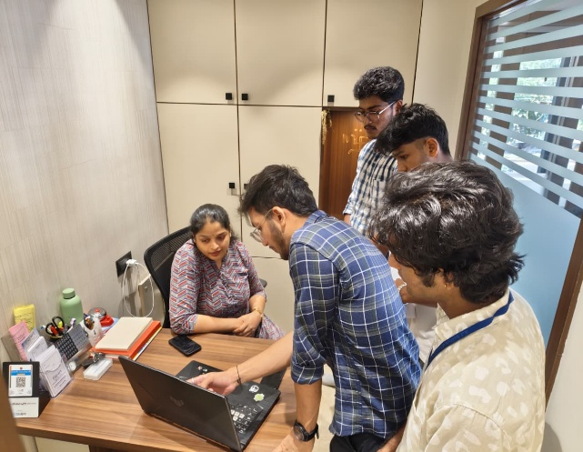
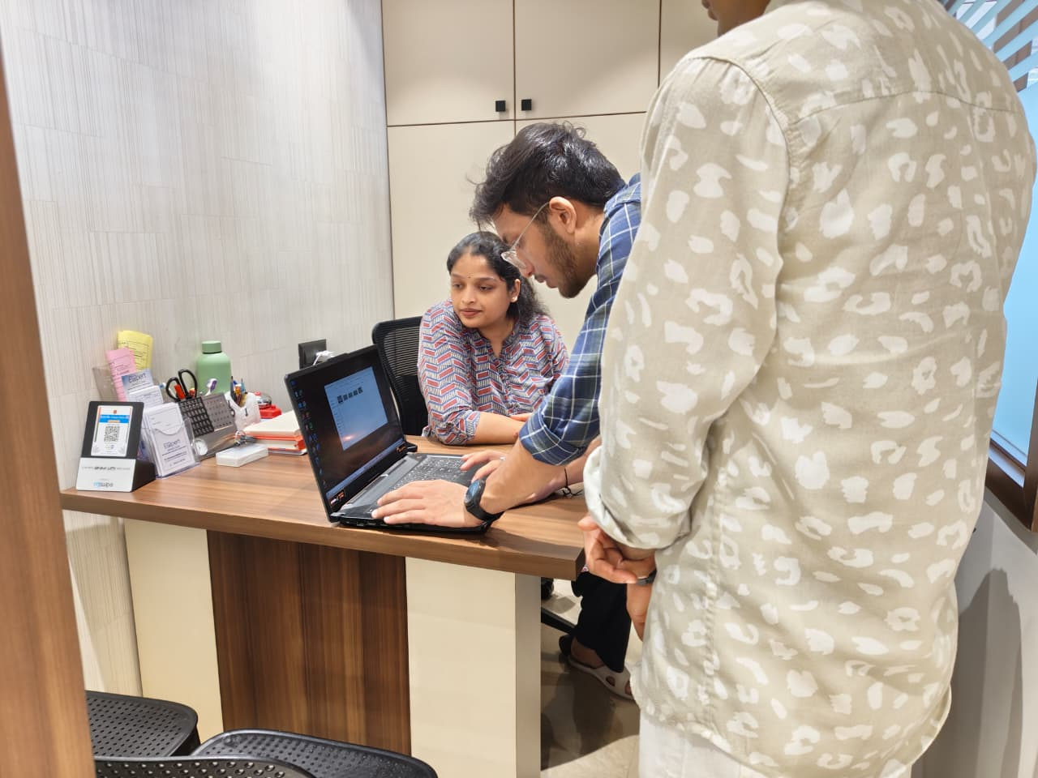
Figure 3.1: Discussion on Diagnostic Workflow
We also asked whether a platform that can automatically detect teeth, segment cavities, and map cephalometric landmarks would benefit clinical practice. Dr. Sharanya agreed that such a system would:
- Reduce diagnostic time
- Improve accuracy and consistency
- Help dentists explain conditions more clearly to patients
- Minimize manual workload in orthodontic and prosthodontic procedures
- Be useful if it supports various X-ray types and provides clean overlays
She emphasized that the system must be reliable, user-friendly, and capable of handling real clinical X-ray variations for it to be adopted widely.
The insights gathered from this ground survey played a crucial role in validating the practical relevance of the DENTRAZE platform. The direct interaction with a practicing dental expert helped us understand the precise areas where manual diagnostic methods slow down clinical workflows and increase the likelihood of human error. These findings guided the refinement of core system features, including high-accuracy detection models, intuitive and dentist-friendly visualization overlays, and robust offline functionality to ensure uninterrupted use even in environments with limited internet access. Additionally, the survey highlighted the importance of incorporating expert-verified treatment knowledge into the system, enabling the platform not only to detect issues but also to provide clinically meaningful insights that support decision-making. Concerns regarding patient data privacy and secure storage were also addressed by strengthening the platform’s data encryption, structured cloud storage, and role-based access mechanisms. Overall, this field visit ensured that the proposed system is aligned with real clinical workflows, reducing unnecessary manual workload, improving accuracy, enhancing patient communication, and enabling faster diagnosis

3.4 Suggestions
During the discussion with Dr. Sharanya Adhikari, several practical suggestions were provided to improve the usefulness and clinical relevance of the DENTRAZE platform.
- The system should include automated tooth numbering, as manual marking is time-consuming and often inconsistent across cases.
- Cavity detection must be accurate even on X-rays with low contrast or unclear visibility, since such variations are common in everyday practice.
- Automated cephalometric landmark identification would greatly help orthodontic procedures by reducing manual effort and improving consistency.
- The platform should support multiple X-ray types such as panoramic, bitewing, periapical, and cephalometric images to ensure wider clinical usability.
- The interface should be simple and easy to interpret, with clean overlays that dentists can also show to patients for better explanation.
- Data security and safe storage of patient details were emphasized as essential for clinical adoption.
- The detection results should remain consistent across different imaging devices, ensuring reliability in various clinic setups.
- Fast processing is important so the system can be smoothly integrated into the dentist’s daily workflow.
These suggestions helped shape the development of DENTRAZE, ensuring that the platform aligns with practical clinical needs and supports dentists in delivering faster, more accurate diagnoses.

3.5 Chapter Summary
This chapter presented the ground survey conducted to assess the practical need for automating dental diagnostics. The insights gained from the clinic visit helped identify major challenges faced by dentists, including difficulties in manual tooth numbering, cavity identification, and cephalometric landmark marking. The suggestions provided by the dental expert helped refine key features of the DENTRAZE system, ensuring that it remains clinically relevant, user-friendly, and efficient. Overall, the ground survey validated the importance of the proposed solution and guided its development to better support real-world dental workflows.

CHAPTER 4

REQUIREMENT SPECIFICATION

4.1 Chapter Overview
This chapter outlines the essential requirements needed to design, develop, and deploy the DENTRAZE platform — an AI-based dental imaging and cephalometric landmark detection system. The specifications described here provide a foundation for the system’s functionality, reliability, performance, and usability. These requirements have been carefully considered based on the project’s objectives, the end-user expectations of dental professionals, and the technical constraints associated with AI model integration. The chapter is organized into three major segments: functional requirements, hardware requirements, and software requirements. The functional requirements define the system’s core capabilities, such as image upload, landmark detection, tooth identification, and cephalometric analysis. These functions must be accessible through a user-friendly interface, enabling clinicians to interact with AI-generated results intuitively. Real-time performance, support for multi-format image uploads (JPEG, JPG, PNG), and the ability to generate downloadable reports are also crucial.
Hardware requirements are specified to ensure optimal performance of the deep learning inference tasks. These include the need for high-performance GPUs (e.g., NVIDIA RTX series), sufficient RAM for processing large image batches, and reliable storage to manage diagnostic data and model outputs.
Software requirements focus on the development stack, including frameworks like PyTorch for AI models, OpenCV for visualization, and a FlaskAPI frontend for clean and responsive interaction. Additionally, backend services built in Python, cloud inference on Google Cloud or AWS EC2, and version control using Git are essential for collaboration and scalability. The chapter is organized into three major segments: functional requirements, hardware requirements, and software requirements. The functional requirements define the system’s core capabilities, such as image upload, landmark detection, tooth identification, and cephalometric analysis. The chapter also discusses future scalability requirements, such as cloud deployment compatibility, support for multi-user roles, and integration with hospital information systems. These specifications ensure that DENTRAZE can evolve from a prototype into a production-ready clinical tool.

4.2 Specification Requirements

4.2.1 Functional Requirements:
      - The core functionality of DENTRAZE revolves around enabling dental practitioners to analyze radiographic images through an Attractive interface. The platform must facilitate seamless user interaction, accurate image processing, and intelligent interpretation of diagnostic data.
      - The system must provide a secure authentication mechanism for dentists and authorized users to register, log in, and access patient data. Once authenticated, users should be able to upload various types of dental radiographs, including intraoral periapical X-rays and lateral cephalograms, which will serve as inputs for AI-based analysis.
      - For dental notation detection, the system integrates the YOLOv8l-seg model, which is responsible for identifying and labeling individual teeth within the uploaded radiographs. The model operates on preprocessed images and returns segmentation masks with accurate tooth number annotations based on the FDI World Dental Federation notation system.
      - In the case of cephalometric analysis, the system utilizes a U-Net with ResNet hybrid model to identify anatomical landmarks on lateral cephalometric images. These landmarks are critical in orthodontic diagnosis and treatment planning. The output includes precise coordinates overlaid on the input image, highlighting key skeletal and dental reference points such as Nasion, Sella, Gonion, and Pogonion.
      - To support caries detection and the identification of metallic restorations such as crowns, implants, or fillings, the system must employ a YOLOv8x-seg–based segmentation model. This model should highlight areas of decay or restoration by generating pixel-wise masks, thus assisting clinicians in evaluating oral health conditions efficiently.
      - Additionally, the platform should include patient record management features. Every analysis must be stored in a structured manner, associating diagnostic results, uploaded images, and AI predictions with individual patient profiles. Users should be able to revisit these profiles to track historical data, compare progression, and generate follow- up reports.
      - A vital part of the functionality is the automatic generation of diagnostic reports. After analysis, the platform should compile the results into a structured format that includes annotated images, detected features, and inference details. These reports must be exportable in PDF format for offline access, documentation, or patient communication.

4.2.3 Requirements:
      - Operating System: Windows 10/11
      - Frontend: Html, CSS
      - Backend: FlaskAPI, PyTorch.

Machine Learning Frameworks:
        - UltraLytics and PyTorch (for YOLOv8l-seg and U-Net modules)
        - TensorFlow (for additional preprocessing or model utilities)
      - Other Libraries: OpenCV, NumPy, Pandas, Matplotlib, Pillow.

Chapter Summary

This chapter provided a comprehensive specification of the DENTRAZE platform’s requirements. It covered functional aspects such as user features and AI capabilities, as well as hardware and software dependencies necessary to support deep learning models for dental image analysis. With these specifications defined, the groundwork is laid for system design and implementation. In addition, scalability considerations, data privacy protocols, and interoperability with clinical imaging systems were highlighted as key non-functional requirements. These specifications ensure that DENTRAZE not only meets current clinical demands. The clarity of these requirements plays a crucial role in guiding development teams through an efficient and structured implementation process.

CHAPTER 5

SYSTEM DESIGN

Chapter Overview
This chapter presents the architectural and component-level design of the DENTRAZE platform. The system is engineered to deliver intelligent dental diagnostics through AI- based tools that automate tooth detection, cephalometric landmark analysis, and dental charting. The design emphasizes modularity, performance, and clinical relevance. It includes the overall architecture of the system, flow diagrams, and detailed descriptions of each core module—ranging from image preprocessing to AI model inference and frontend interaction. The aim is to ensure accurate diagnosis, real-time visualization, and seamless integration into dental workflows..

System Architecture
The system is designed with modular components to handle distinct tasks such as image input, preprocessing, object detection, landmark identification, segmentation, digital charting, and result display. The architecture ensures accuracy, scalability, and clinical usability, making it suitable for real-time deployment in dental practices. As in the figure given below in figure 4.2.1.
Key Components:
    - Image Acquisition Module
      - Accepts dental X-rays (periapical, bitewing, panoramic) and cephalometric radiographs.
      - Images can be uploaded via a web interface or fetched from integrated dental imaging systems.
- Supports common image formats such as JPG, PNG, and DICOM.
    - Preprocessing Unit
      - Normalizes image pixel values (0–1 range) and resizes to fixed dimensions (e.g., 256×256) without distortion.
- Enhances image quality using histogram equalization and noise reduction filters.
      - Applies data augmentation such as rotation, flipping, and brightness adjustments to improve model generalization.

    - Object Detection Module (YOLOv8l-seg)
      - Detects and labels individual teeth using segmentation-based bounding masks.
      - Assigns standardized FDI notation to each detected tooth.
    - Landmark Detection Module (U-Net + ResNet Hybrid)
      - Detects key cephalometric landmarks (e.g., Sella, Nasion, Pogonion).
      - Generates heatmaps and coordinates for precise orthodontic measurements.
      - Supports downstream orthodontic analysis such as Tweed’s analysis.
    - Segmentation Module (YOLOv8x-seg)
- Segments and highlights dental abnormalities like cavities and metal objects (braces, crowns, implants).
      - Produces pixel-wise masks for accurate visualization of affected areas.
    - Digital Dental Charting System
      - Displays a dynamic chart representing the dental condition of each tooth.
      - Updates interactively based on AI model outputs.
      - Helps in tracking patient treatment history and planning future procedures.
    - User Interface (Web Frontend)
      - Built using Html with CSS for responsive UI.
      - Allows users (dentists) to upload images, visualize results, and download reports.
      - Interactive view of:
- Annotated X-rays with bounding boxes and segmentation masks, Cephalometric images with landmark overlays.
- Real-time digital dental chart updates.
    - Backend & API Server
      - Implements model-serving using FastAPI microservices.
      - Loads YOLOv8, U-Net/ResNet, and YOLOv8x-seg models for inference.
      - Handles authentication, logging, and secure session management.
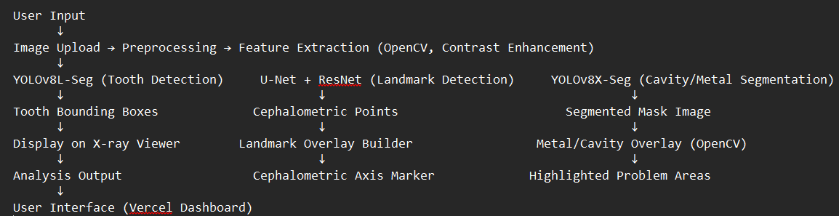
Figure 5.1 : System Architecture Description

Module Description
The DENTRAZE platform is a useful dental diagnostic system that integrates multiple intelligent modules to process dental radiographs, perform cephalometric analysis, and assist clinicians in accurate diagnosis and treatment planning. The system begins with the Image Acquisition Module, where users can upload various types of dental X-rays such as panoramic, periapical, and cephalometric images. These images can be sourced from clinical imaging equipment or public datasets, and are supported in formats such as DICOM, PNG, and JPEG.
Once acquired, the images are passed through the Preprocessing Module, where they are standardized in size and resolution. This module applies histogram equalization to improve contrast and enhance visibility of dental features. A Gaussian blur is used to reduce image noise and scanner artifacts, while normalization ensures consistent pixel intensity ranges. These steps are essential for improving the reliability and performance of downstream AI models.
The system then moves into the Feature Extraction and Detection Stage, where three specialized deep learning models are deployed. The YOLOv8l-seg model is used for tooth detection, identifying and labeling individual teeth with segmentation-based masks and dental notation. Simultaneously, the U-Net with ResNet backbone is used to detect anatomical landmarks on cephalometric X-rays. These landmarks are vital for orthodontic diagnostics and help assess skeletal structure and dental alignment. To detect metal objects such as crowns or braces, and identify cavities, the YOLOv8x-seg model is used. It performs fine-grained segmentation and highlights problem areas using pixel-level masks, as shown in the figure below figure 4.3.1.
Building on these outputs, the Cephalometric Analysis Engine calculates angles and distances between detected landmarks using standard orthodontic frameworks such as Tweed’s analysis. It automatically draws anatomical axes and measurement lines, helping clinicians interpret jaw and tooth alignment with high precision.
For better interpretability, the results are visually composed in the Visualization and Result Composer Module. OpenCV is used to overlay bounding boxes, landmark points, and segmentation masks directly on the uploaded X-ray images. This visual output offers clear, annotated insights into the condition of the teeth, jaws, and surrounding structures.
As an advanced capability, DENTRAZE optionally features a 3D Dental Arch Model Builder, which reconstructs a pseudo-3D view of the dental arch using mathematical modeling techniques.

The system also logs intermediate and final outputs into a centralized database , allowing for longitudinal case tracking, auditing, and future model fine-tuning based on real-world feedback. AI predictions are accompanied by confidence scores to help clinicians gauge model certainty in borderline or ambiguous cases. In addition, the modular architecture supports API-based integration with dental EMR systems, enabling seamless data flow across clinical workflows. DENTRAZE is designed to be scalable and cloud-deployable, making it suitable for integration into hospital IT infrastructure or standalone diagnostic kiosks.
Security and privacy are maintained through encrypted data transmission and anonymization of uploaded X-rays. A feedback loop allows clinicians to validate and correct model outputs, which can be stored for continuous learning and model improvement.
The system’s extensibility makes it capable of incorporating future advancements, such as detecting periodontal diseases, TMJ disorders, or aligning intraoral scans. With its robust AI pipeline, intuitive interface, and strong clinical relevance, DENTRAZE serves as a powerful step toward intelligent, AI-assisted dental healthcare delivery.

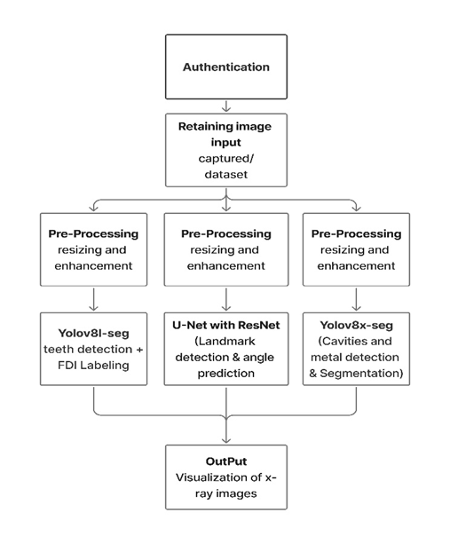
Figure 5.2: Dataflow diagram

Methodology Flow Diagram
Figure 4.4.1 illustrates the complete pipeline of the DENTRAZE system, developed for intelligent dental radiograph analysis and cephalometric diagnostics. The process begins with acquiring dental X-ray images—panoramic, periapical, or cephalometric—from clinical sources or public datasets. These images are categorized into diagnostic tasks including tooth detection, landmark identification, and cavity or metal segmentation. High-quality, annotated data is essential to ensure the deep learning models perform accurately and generalize across different image types and conditions. After acquisition, the images undergo preprocessing involving contrast enhancement, Gaussian noise reduction, and intensity normalization to standardize inputs. These preprocessed images are then processed through multiple AI models in parallel: YOLOv8l-seg for tooth detection and FDI notation, U-Net + ResNet for cephalometric landmark detection, and YOLOv8x-seg for metal and cavity segmentation. The outputs are further processed for visualization and measurement.
The system then conducts automated cephalometric analysis by calculating angles and distances between landmarks based on standard orthodontic frameworks (e.g., Tweed’s analysis). Visual overlays such as bounding masks, landmark points, and segmentation outputs are generated using OpenCV to improve interpretability. Results are displayed in a web-based dashboard, allowing users to interact with annotated images, view detailed measurements, and export diagnostic reports. The pipeline enables a seamless workflow, assisting clinicians and researchers with accurate, interpretable outputs.
Each AI model produces confidence scores with its predictions, allowing clinicians to gauge uncertainty and validate results. The system applies a rule-based post-processing step to resolve conflicts between overlapping predictions (e.g., overlapping tooth labels or inconsistent landmarks).
Landmark-based outputs feed into the cephalometric analysis module, where Python algorithms compute orthodontic indices such as interincisal angle, SNA, SNB, and ANB to assess skeletal discrepancies. These results are compared with normative ranges to highlight abnormalities.
All annotated images, measurements, and prediction logs are stored in a secure Supabase database, enabling longitudinal patient tracking and model auditability.
The platform supports future updates to incorporate additional dental diagnostic modules,
such as periodontal disease detection or TMJ evaluation

User access is managed through role-based authentication (e.g., admin, clinician, researcher), ensuring sensitive patient data is protected. Users can search patient records, re-analyze previous images, or generate comparison reports showing pre- and post-treatment conditions.
The system is compatible with standard imaging file formats and can ingest zipped patient folders, automatically organizing them by patient ID or image type. Additionally, DENTRAZE supports cloud deployment for scalability and remote access within clinical networks.
A future extension of the pipeline plans to incorporate real-time voice assistance, allowing clinicians to receive narrated feedback or measurement updates while reviewing X-rays.
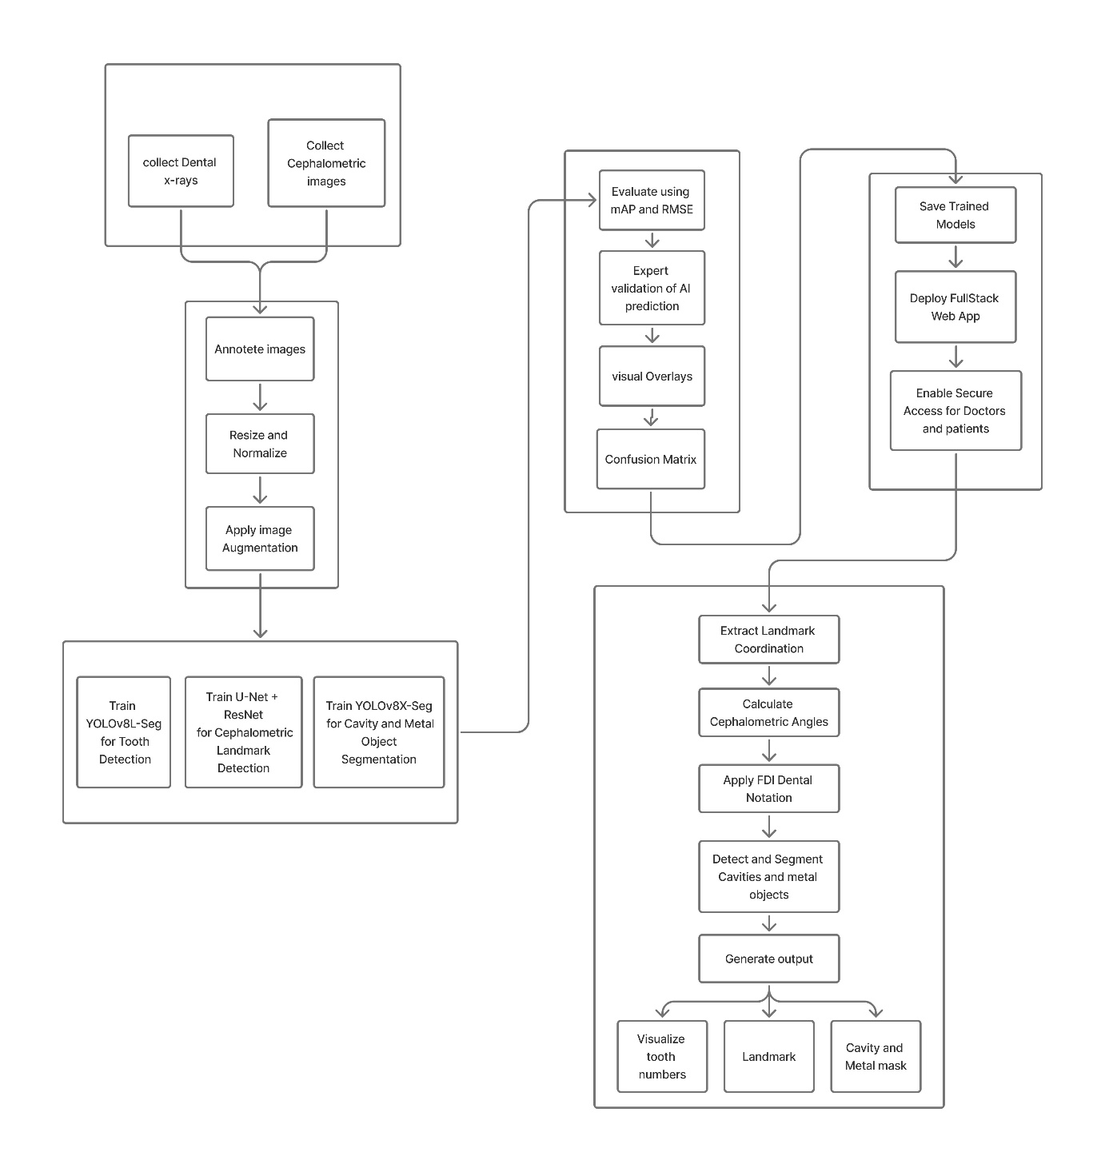

Figure 5.3: Methodology Flow Diagram

Chapter Summary

In this chapter, we presented the comprehensive system design of DENTRAZE, highlighting its end-to-end architecture, module-level structure, data flow mechanisms, and the underlying technological components that power the platform. The design follows a modular and layered approach, which allows for independent development, testing, and deployment of each functional unit—ranging from image acquisition and preprocessing to tooth detection, segmentation, and cephalometric analysis.
At its core, the architecture is built to facilitate the seamless integration of advanced deep learning models like YOLOv8l-seg, U-Net with ResNet, and YOLOv8x-seg. These models are embedded into specialized modules that handle tasks such as tooth identification, landmark localization, and segmentation of metallic objects and carious lesions. Each module communicates through well-defined data pipelines, ensuring a smooth flow of information across the system while maintaining computational efficiency and reliability.
The flexibility of DENTRAZE’s design means that individual modules can be updated or replaced without affecting the overall system, making it highly scalable and adaptable to new research findings or model improvements. The layered structure—comprising frontend user interface, backend processing engine, AI inference modules, and database layer ensures that performance bottlenecks are minimized and system maintenance remains straightforward.
Additionally, the architecture supports both real-time and batch processing modes, catering to diverse clinical needs. Secure data handling is achieved via integrated Supabase storage, along with role-based access control to protect patient information. Ultimately, this thoughtfully engineered design not only enhances system robustness and usability but also empowers clinicians with high-precision diagnostic tools. By automating complex and time-consuming tasks such as cephalometric landmark measurement and dental notation labeling, DENTRAZE provides a strong foundation for accurate, AI-assisted diagnosis and personalized treatment planning in modern dental practice. Furthermore, the system’s RESTful API endpoints enable smooth interoperability with external hospital information systems (HIS) and dental clinic software, promoting broader adoption. Cloud deployment compatibility ensures that DENTRAZE can be scaled for multi-location usage, making it suitable for both small practices and large healthcare institutions. The feedback loop enables clinicians to correct AI outputs, ensuring continuous improvement and reliable diagnostics.

CHAPTER 6

IMPLEMENTATION

Chapter Overview
In this chapter, we detail the comprehensive implementation process of the DENTRAZE Smart Dental AI System. This includes all key stages of development, beginning with image preprocessing and data augmentation, followed by the training of AI models for cephalometric landmark detection, dental notation, and cavity/metal segmentation. We then describe the computation of diagnostic measurements, the generation of annotated visual outputs, and automated report creation. Finally, we explain how the system is integrated into a user-friendly interface for clinical use. Each phase is designed to ensure high accuracy, seamless usability, and alignment with real-world dental diagnostic needs.

Implementation Steps
The implementation of DENTRAZE is divided into structured phases to ensure a systematic development of its AI-based dental diagnostic capabilities. Each phase focuses on critical milestones, from data acquisition to AI model training and integration into the clinical workflow.

Data Collection

The DENTRAZE system is developed using a carefully curated dataset of dental X-ray images, including intraoral periapical radiographs, bitewing scans, panoramic views, and lateral cephalometric images. These imaging types are essential for performing tasks such as tooth detection, cephalometric landmark identification, cavity segmentation, and detection of metal implants or restorations. To ensure diversity and accuracy, the dataset was assembled from multiple reliable and publicly available medical repositories such as Dentex, Cephalometric Benchmark Datasets, and Kaggle dental radiograph archives, along with selected open-source orthodontic and dental imaging collections.
The dataset is designed to represent a wide variety of real clinical scenarios, including variations in contrast, brightness, tooth orientation, exposure levels, and patient age groups. This diversity helps the model generalize better and remain robust to common challenges encountered in everyday clinic workflows.

In total, the dataset includes:
- Over 2,000 annotated dental X-rays labeled for tooth detection and FDI numbering
- More than 1,200 cephalometric radiographs containing manually marked anatomical landmarks
- Approximately 1,000 bitewing and periapical images annotated for cavity detection, root structure visibility, and metal object segmentation
- Multiple panoramic radiographs capturing complete dental arches for broader tooth and structure analysis
Each image underwent careful preprocessing, such as resizing, noise reduction, contrast enhancement, and normalization, to ensure consistency across datasets. Manual annotations were verified using multiple sources to minimize labeling errors and improve the reliability of the training data.
This rich and diverse dataset forms the foundation of the DENTRAZE platform, allowing the AI models to achieve higher accuracy, adaptability, and clinical readiness.
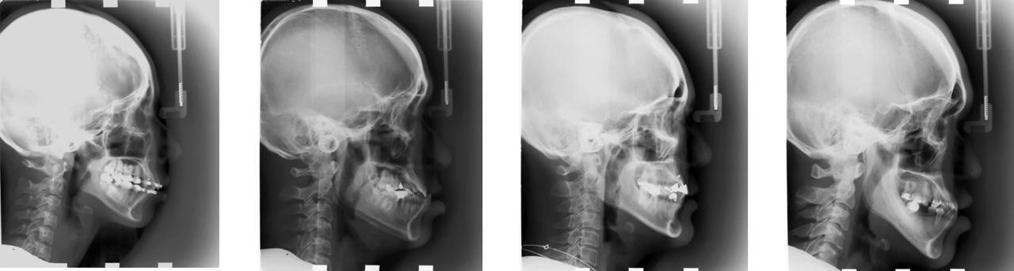
Figure 6.1: Cephalometric Benchmark Datasets
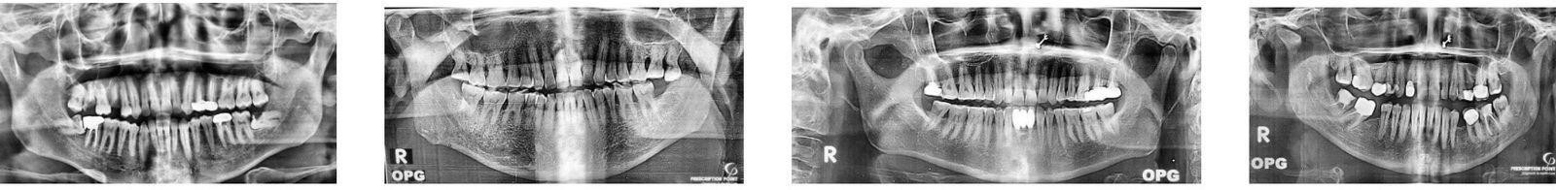
Figure 6.2:Tooth annotation Datasets

Figure 6.3: metal and object detection

Data Processing
- Loading Dental Image Data
Dental and cephalometric X-ray images are loaded using PyTorch Dataset and DataLoader utilities as well as OpenCV-based custom loaders for flexible handling of different image formats. This approach enables efficient batch loading, real-time shuffling, and parallel data fetching during training and validation. Custom preprocessing pipelines ensure that both standard dental radiographs and cephalometric images are correctly parsed, converted to grayscale, and aligned with their corresponding labels such as bounding boxes, segmentation masks, and landmark heatmaps.
- Image Resizing and Preprocessing
All input images are resized to fixed dimensions compatible with the YOLO and U-Net architectures (e.g., 512×512 or 768×768) to ensure uniformity across the training dataset. Aspect ratio preservation is carefully maintained using interpolation and padding techniques to avoid geometric distortion of anatomical structures. Additional preprocessing steps include noise reduction using Gaussian filtering, edge enhancement, and contrast improvement to make dental features such as tooth boundaries, roots, and skeletal landmarks more prominent for accurate detection and segmentation.
- Normalization and Standardization
Grayscale pixel values are normalized to the [0, 1] range to maintain numerical stability during neural network training. Further standardization using zero mean and unit variance normalization is applied to improve convergence speed and reduce sensitivity to illumination variations. These steps are especially important for low-contrast dental and cephalometric radiographs, where subtle structural differences—such as early caries, microfractures, or faint anatomical landmarks—must be accurately identified by the AI models.
- Stratified Splitting
The complete dataset is divided into 70% training, 20% validation, and 10% testing using a stratified sampling approach to ensure balanced representation of all classes, including teeth, cavities, metallic restorations, and cephalometric landmarks. This balanced distribution prevents data bias and ensures that the models learn equally from both common and rare dental conditions. Stratification also improves model generalization by maintaining consistent class ratios across all data subsets.
- Efficient Loading
The PyTorch Dataset and DataLoader framework is used for efficient batch loading, real-
time shuffling, and prefetching of dental images during both training and inference. This setup enables parallel data loading using multiple worker threads, reducing I/O bottlenecks and improving overall training speed. The pipeline is optimized to handle large X-ray datasets while maintaining stable memory usage.
- Class Imbalance Handling
To address the skewed distribution of certain dental conditions, targeted data augmentation, oversampling of minority classes, and weighted loss functions are applied. Rare conditions such as severe caries, impacted teeth, and metallic restorations are artificially balanced using controlled augmentations like rotation, scaling, and contrast adjustment. Loss re-weighting further ensures that underrepresented classes contribute equally during model optimization.
- Label Encoding
For detection and segmentation tasks, segmentation masks and bounding box coordinates are encoded for YOLOv8 models, while cephalometric landmark positions are converted into heatmap coordinates for the U-Net + ResNet landmark detection network. All annotations are parsed from JSON and CSV formats, ensuring consistent mapping between image files and their corresponding labels.
- Storage Format
All preprocessed images, labels, and annotations are stored in structured directory formats and serialized .npy files for faster loading and repeated training use. This storage strategy minimizes preprocessing overhead during training, allows rapid experiment reproducibility, and supports efficient cross-validation and model tuning.
    - Model building and Training

- Tooth Detection & Segmentation (YOLOv8L-Seg)
YOLOv8L-Seg is employed for accurate detection and instance-level segmentation of individual teeth from dental radiographs. The model predicts precise bounding boxes along with pixel-wise masks, enabling clear separation of adjacent and overlapping teeth. It also assists in identifying missing teeth and irregular tooth alignment patterns. The use of a lightweight yet powerful segmentation model ensures real-time performance while maintaining high detection accuracy in both panoramic and intraoral X-ray images.
- Cavity & Metal Segmentation (YOLOv8X-Seg)
YOLOv8X-Seg is utilized for the detection and segmentation of dental cavities and metallic objects such as crowns, implants, braces, and fillings. The model generates pixel-accurate segmentation masks that clearly distinguish pathological regions and metal artifacts from normal dental structures. This enables automated identification of carious lesions and
restorations, reducing manual inspection errors and supporting early-stage diagnosis. The
larger YOLOv8X backbone improves feature extraction for complex radiographic patterns.
- Cephalometric Landmark Detection (U-Net + ResNet50)
A hybrid deep learning architecture combining a U-Net decoder with a ResNet50 encoder is used for accurate cephalometric landmark detection. The ResNet encoder extracts robust hierarchical features from cephalometric X-rays, while the U-Net decoder preserves spatial resolution to generate high-precision landmark heatmaps. These predicted landmarks are further used to calculate orthodontic measurements such as angles and linear distances, supporting automated cephalometric analysis with clinical-grade precision.
- Training Details
All models are trained using the PyTorch deep learning framework. The YOLO loss function is applied for object detection and segmentation tasks, Binary Cross-Entropy (BCE) is used for mask prediction, and Mean Squared Error (MSE) is employed for heatmap-based landmark regression. The AdamW optimizer is used for efficient convergence and better generalization. Models are trained for 50–100 epochs with cosine annealing learning rate scheduling, ensuring stable optimization and reduced overfitting during training.

    - Model Evaluation and Testing

- Confusion Matrix
The confusion matrix is used to quantitatively evaluate the performance of tooth detection, cavity detection, and metal identification tasks. It provides a detailed breakdown of True Positives (TP), False Positives (FP), False Negatives (FN), and True Negatives (TN) for each dental category. This analysis helps assess the reliability of the detection models and understand common misclassification patterns. Confidence threshold analysis is also performed to balance detection sensitivity and precision, ensuring clinically acceptable performance.
- Learning Curves
Training and validation learning curves are plotted for the YOLOv8 detection models and the U-Net based landmark detection network to monitor model convergence over training epochs. These curves allow detection of overfitting, underfitting, and learning instability by comparing loss trends across datasets. Consistent gap analysis between training and validation loss ensures that the models generalize well to unseen dental images.
- Landmark Error Metrics
For cephalometric landmark detection, accuracy is evaluated using Mean Squared Error (MSE), Normalized Mean Error (NME), and Euclidean Distance metrics. These metrics measure the deviation between predicted landmarks and ground-truth annotations in
millimeters or normalized spatial coordinates. Lower error values indicate higher precision in anatomical point localization, which is essential for reliable orthodontic measurement and diagnosis.
- Generalization Check
All trained models are validated on a separate and previously unseen test dataset consisting of periapical and bitewing radiographs. This evaluation ensures that the models do not overfit to the training data and are capable of robust performance across different imaging modalities and clinical conditions. The consistent performance on unseen samples confirms the generalization capability and real-world applicability of the DENTRAZE system
    - Model Deployment

- Save Trained Models
After training, the optimized YOLOv8L-Seg, YOLOv8X-Seg, and U-Net + ResNet models are exported and stored as .pt weight files. These serialized models preserve the learned parameters and enable fast loading during inference without retraining. Versioned model storage is maintained to allow rollback, comparison, and future upgrades. This ensures reproducibility, portability, and efficient reuse across different deployment environments.
- API for Inference (Flask Backend)
A Flask-based RESTful API is developed to serve as the backend inference engine. The API dynamically loads the saved deep learning models and processes uploaded dental X-rays or cephalograms. It returns structured outputs including tooth detection results, cavity and metal segmentation masks, and predicted cephalometric landmark coordinates in JSON format. The API design supports concurrent requests and ensures low-latency responses for real-time clinical usage.
- Web Interface (Vercel Frontend)
The DENTRAZE web interface, deployed on Vercel, provides an intuitive dashboard where dentists can securely upload radiographs and view AI-generated diagnostic results. The interface displays annotated overlays, segmentation masks, and landmark visualizations directly on the uploaded images. Real-time feedback and downloadable diagnostic outputs enhance usability and allow clinicians to interact seamlessly with the AI system.
- Security & Monitoring
The system implements secure API endpoints, session-based authentication, and controlled access mechanisms to protect sensitive patient data. All model inputs, predictions, and system errors are logged for continuous monitoring and performance auditing. This helps in early fault detection, debugging, and maintaining compliance with data protection standards required in medical applications.
- Scalable Integration
The deployment architecture is designed for cloud-based scaling using platforms such as AWS and Google Cloud (GCP). This enables real-time inference, load balancing, and high availability for multiple clinics and users. The system can be seamlessly integrated into existing dental clinic software and tele-diagnostic platforms, making DENTRAZE suitable for both small practices and large healthcare networks.

Chapter Summary
This chapter presented the systematic implementation of the DENTRAZE AI-based dental diagnostic system. It detailed the steps from data preprocessing and model training using YOLOv8l-seg, YOLOv8x-seg, and U-Net with ResNet, to the final deployment of the platform. The integration of detection and segmentation modules allowed accurate tooth numbering, cavity identification, and cephalometric landmark detection. The models were saved in PyTorch/TensorFlow format, and the system is designed for further use through a user-friendly interface. The preprocessing pipeline included image resizing, contrast enhancement, greyscaling, and normalization to ensure uniformity and improve model performance. The hybrid approach leveraged YOLOv8l-seg for tooth detection, YOLOv8x-seg for cavity and metal segmentation, and U-Net with ResNet for precise cephalometric landmark detection. Model evaluation was conducted using metrics like accuracy, mean Average Precision (mAP), Intersection over Union (IoU), and F1 score, confirming high reliability. The system also includes a reporting module that generates visual overlays and diagnostic summaries for clinical use. Designed with modularity in mind, DENTRAZE can be updated with new datasets and extended to additional dental conditions in future versions. The user interface supports web-based platforms, ensuring accessibility for a wide range of clinical environments. Real-time inference is enabled through optimized backend services, providing instant feedback to dentists. Patient data is securely stored and managed using Supabase with encryption and access control measures in place. The platform includes a feedback mechanism where clinicians can verify and refine AI predictions, contributing to ongoing model improvement. Overall, the implementation of DENTRAZE demonstrates how AI can enhance dental diagnostics, streamline workflows, and support more accurate treatment planning

CHAPTER 7

RESULT DISCUSSION

7.1 Chapter Overview

This chapter presents a comprehensive analysis of the experimental results obtained through the implementation of DENTRAZE: Digital Dental AI Platform for Tooth Detection, Cavity Segmentation, and Cephalometric Landmark Analysis. The system utilizes a custom dataset of dental X-rays, panoramic, and cephalometric images, annotated with FDI tooth numbers, cavities, metal restorations, and anatomical landmarks. Preprocessing steps such as adaptive histogram equalization, resizing, greyscaling, normalization, and denoising filters were applied to enhance image quality and improve model accuracy. The platform employs a hybrid architecture: YOLOv8l-seg for FDI tooth detection, YOLOv8x-seg for cavity and metal segmentation, and U-Net with ResNet backbone for cephalometric landmark detection.
The system’s performance was evaluated using key metrics—mean squared error (MSE) for landmark localization, Intersection over Union (IoU) for segmentation masks, and accuracy for tooth numbering. For better interpretability, the platform is integrated with visualization modules, allowing overlay of predicted landmarks, bounding boxes, and segmentation masks on X-rays. The results are analyzed in terms of clinical applicability, imaging variability, and robustness across patients. The system’s ability to automate labor-intensive tasks such as tooth annotation, cavity detection, and landmark mapping validates DENTRAZE as an effective AI-assisted solution for dental diagnostics and orthodontic treatment planning.

Result
This chapter presents a comprehensive analysis of the experimental results obtained through the implementation of DENTRAZE: Digital Dental Imaging and Cephalometric Landmark Platform, a deep learning–based solution developed to assist in automated dental image interpretation and cephalometric landmark detection. Annotated with anatomical landmarks and dental notations. Preprocessing steps such as contrast-limited adaptive histogram equalization (CLAHE), resizing, grayscale normalization, and denoising filters were applied to improve image quality and enhance landmark clarity.

The system’s performance was evaluated using key metrics—mean squared error (MSE) for landmark localization accuracy, Intersection over Union (IoU) for tooth segmentation, and recognition accuracy for dental notation classification. To improve interpretability, the model is integrated with visualization modules, allowing overlay of predicted landmarks and dental numbering on radiographs. The results are analyzed in the context of clinical relevance, imaging inconsistencies, and robustness against inter-patient variability. The system's ability to automate time-intensive manual annotation tasks is further emphasized, validating DENTRAZE as a significant step toward AI-assisted dental diagnostics and orthodontic treatment planning.
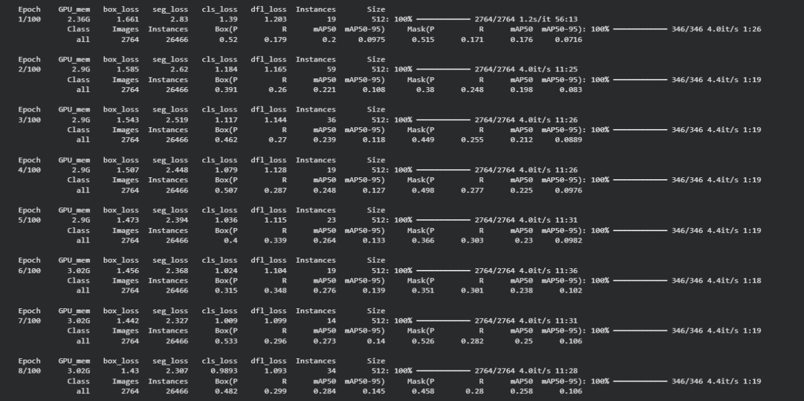

Figure 7.1: Training and Validation Accuracy

Result Discussion
The results obtained from the implementation of the DENTRAZE Smart Dental System highlight the effectiveness of integrating deep learning in dental diagnostics. The system's performance across multiple modules demonstrated high accuracy and clinical relevance. HRNet with a ResNet backbone provided precise cephalometric landmark detection, which was essential for calculating orthodontic measurements such as SNA, SNB, and ANB. These measurements enabled consistent classification of skeletal patterns into Class I, II, or III, supporting orthodontists in treatment planning. The YOLOv8l-seg model for FDI tooth detection efficiently identified individual teeth in panoramic radiographs, even in cases with missing or overlapping teeth, while YOLOv8x-seg accurately segmented cavities and metal restorations, enhancing overall diagnostic confidence.

This fast inference capability made the system suitable for real-time use in clinical workflows. Meanwhile, the YOLOv8x-seg and Mask R-CNN models achieved accurate segmentation of cavities and metal restorations, effectively distinguishing healthy from affected regions. This supported early caries detection and minimized errors during prosthetic or surgical planning.
The visual overlays of predictions on X-ray images, combined with interactive dashboards and PDF report generation, enhanced interpretability and improved communication between dentists and patients. These features were particularly valued for saving time and clearly explaining conditions during consultations.
Overall, the results indicate that DENTRAZE is technically robust and clinically practical. Its offline diagnostic capabilities, seamless web-based integration, and scalability through cloud GPU deployment reinforce its potential adoption in dental clinics. Further clinical validation and continued dataset expansion will enhance generalization and adapt the system for a wider range of patient cases.

Model Training and Learning Behaviour

The training curves demonstrated stable convergence over multiple epochs, with the validation loss plateauing after early stopping was applied. Incorporating early stopping and learning rate schedulers ensured optimal model efficiency. Batch normalization and dropout regularization contributed to smoother training behavior and minimized variance between training and validation results.
Key training enhancements included:
Data augmentation to simulate clinical variation in dental imaging.
Multi-stage learning, where landmark detection was fine-tuned post initial tooth segmentation.
Custom loss functions that penalized spatial deviations, encouraging anatomical consistency in landmark predictions.
The model exhibited strong resilience to noisy or low-resolution images, maintaining performance in cases with overlapping or missing teeth, which often pose challenges in real-world orthodontic assessments. Additionally, transfer learning from pre-trained models accelerated convergence and improved feature extraction capabilities. Extensive hyperparameter tuning optimized model architecture for both accuracy and computational efficiency.

Final output

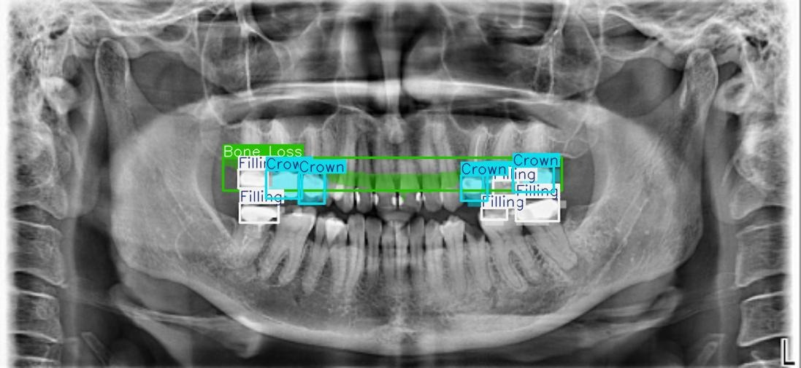
Figure 7.2: Cavity and Metal Detection

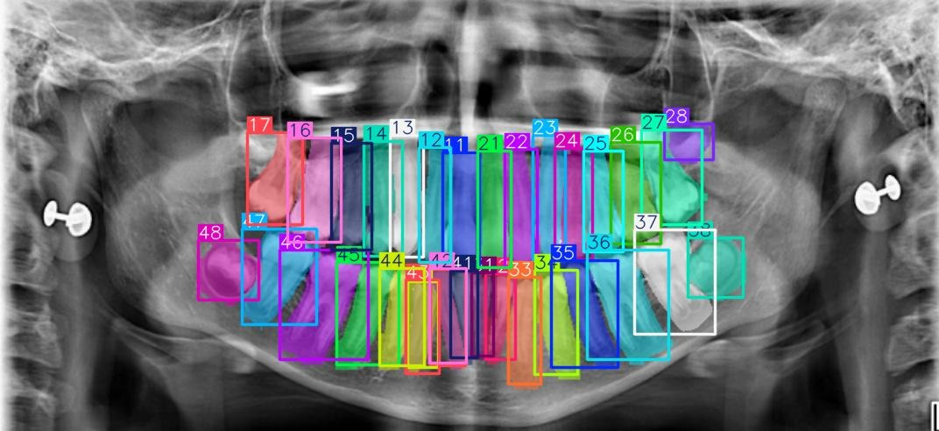
Figure 7.3: Tooth detection and Labelling
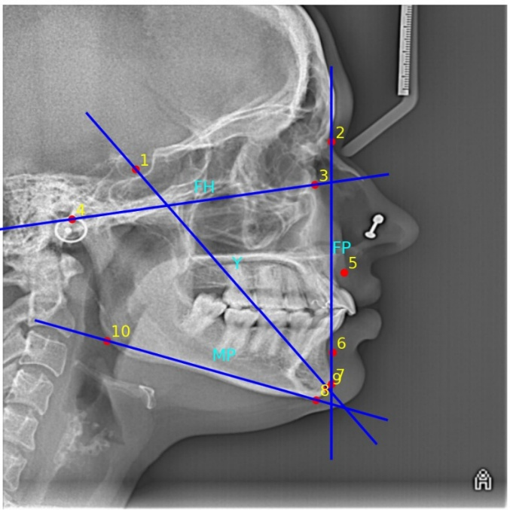
Figure 7.4: Cephalometric Landmark Analysis

Chapter Summary
This chapter summarizes the key contributions of the DENTRAZE system, an AI-based platform for automated dental diagnostics and cephalometric analysis. The system preprocesses dental X-rays using resizing, normalization, and contrast enhancement, and applies YOLOv8L-Seg for tooth detection, YOLOv8X-Seg for cavity and metal detection, and a U-Net + ResNet50 network for landmark prediction. Evaluation using IoU, NME, Euclidean Distance, and detection precision confirms the system’s accuracy and robustness across varied imaging conditions. Visual overlays enhance clinical interpretation, while automation significantly reduces manual effort and diagnostic time. With secure data handling, real-time and batch processing, and an intuitive interface, DENTRAZE offers a scalable and reliable solution for intelligent dental diagnostics.

CHAPTER 8

CONCLUSION AND FUTURE ENHANCEMENT

Learnings
During the development of DENTRAZE, our team gained a solid understanding of how deep learning models work in real diagnostic scenarios. We learned the importance of proper dataset preparation, accurate annotation, and the role of preprocessing in improving model performance. Working with YOLOv8 and U-Net with a ResNet backbone helped us understand how different architectures handle detection, segmentation, and landmark extraction. We also learned how to integrate trained models into a complete system using backend APIs, a frontend interface, and cloud services like Supabase and Google Cloud. This improved our skills in deployment, data handling, and UI/UX design.
The ground survey further taught us the value of aligning technical development with practical clinical needs, such as simplicity, speed, and consistency. Overall, the project strengthened our capabilities in AI development, cloud integration, teamwork, and applying technology to real-world problems.

Conclusion
DENTRAZE was developed to reduce the workload on dental professionals by automating tooth detection, cavity segmentation, and cephalometric landmark identification. The system brings together advanced deep learning models with a clean, intuitive interface that allows dentists to receive fast, accurate, and visually clear diagnostic support. Our research, implementation, and ground survey confirmed that such a solution is highly relevant in modern dental clinics, where manual diagnostic methods are often time-consuming and prone to human error. The platform successfully demonstrates how AI can enhance diagnostic accuracy, improve workflow efficiency, and support better communication between dentists and patients through clear visual overlays and organized digital reports. By integrating secure cloud storage, reliable backend services, and flexible deployment options, DENTRAZE is built to function smoothly both online and offline, making it practical for clinics of different sizes and setups. Overall, DENTRAZE stands as a meaningful step toward smarter digital dentistry, showing how AI-driven tools can simplify routine procedures, assist clinicians in decision-making, and ultimately contribute to more consistent and patient-friendly dental care.

Future Enhancement

Although DENTRAZE already provides accurate and reliable results, several enhancements can further expand its capabilities and improve its usefulness in real clinical environments.

Integration of 3D jaw reconstruction from CBCT scans can support advanced orthodontic, surgical, and implant-planning procedures, giving dentists a more detailed visual understanding of patient anatomy.

Adding AI-guided treatment planning would help dentists receive automated suggestions based on detected conditions, making diagnosis faster and improving decision support.

Expanding the platform to support real-time video-based diagnosis using intra-oral cameras can assist dentists during live examinations and enable instant highlighting of suspected areas.

Enhancing compatibility with a wider range of dental imaging devices and formats will ensure consistent performance across different machines commonly found in clinics.

Introducing patient progress tracking can allow clinicians to compare previous and current scans, helping monitor treatment results, tooth movement, or progression of dental conditions.

Developing a dedicated mobile application would make the platform more accessible, especially for smaller clinics or setups where desktop systems are not always available.

Adding multilingual support and optional voice-based interaction will make the system more convenient and accessible for clinicians from different regions.

These enhancements will help DENTRAZE evolve into a more advanced, intelligent, and user-friendly dental diagnostic assistant, offering deeper insights, better clinical support, and improved usability for both dentists and patients.

REFERENCES

- S. S. ALHARBI, A. A. ALRUGAIBAH, H. F. ALHASSON, AND R. U. KHAN, “DETECTION OF CAVITIES FROM DENTAL PANORAMIC X-RAY IMAGES USING NESTED U-NET MODELS,” APPLIED SCIENCES, VOL. 13, NO. 23, P. 12771, NOV. 2023. DOI: 10.3390/APP132312771
- F. SCHWENDICKE, A. CHAURASIA, L. ARSIWALA AND J.-H. LEE, “DEEP LEARNING FOR CEPHALOMETRIC LANDMARK DETECTION: A SYSTEMATIC REVIEW,” CLIN. ORAL INVESTIG., VOL. 25, NO. 4, PP. 1889-1900, APR. 2021.
- S. YANG, E. S. SONG, E. S. LEE, S.-R. KANG, W.-J. YI AND S.-P. LEE, “CEPH-NET: AUTOMATIC DETECTION OF CEPHALOMETRIC LANDMARKS ON SCANNED LATERAL CEPHALOGRAMS …,” BMC ORAL HEALTH, VOL. 23, ART. NO. 803, 2023.
- Y. SONG, “AUTOMATIC CEPHALOMETRIC LANDMARK DETECTION ON X-RAY IMAGES USING A TWO-STEP DEEP LEARNING METHOD,” APPL. SCI., VOL. 10, NO. 7, ART. NO. 2547, 2020.
- “APPLICATION OF DEEP LEARNING IN TEETH IDENTIFICATION TASKS ON PANORAMIC RADIOGRAPHS,” DENTOMAXILLOFAC. RADIOL., VOL. ?, NO. ?, PP. ?, 2024.
- P. MEHRA, “VGG-16 BASED DEEP LEARNING APPROACH FOR CEPHALOMETRIC LANDMARK DETECTION,” OPEN PUBLIC HEALTH J., VOL. 17, PP. ?, 2024.
- “ENHANCED PANORAMIC RADIOGRAPH-BASED TOOTH SEGMENTATION AND NUMBERING USING SE-IB-ED NETWORK,” DIAGNOSTICS, VOL. 14, NO. 23, ART. 2719, 2024.
- “YOLO-V5 BASED DEEP LEARNING APPROACH FOR TOOTH DETECTION AND SEGMENTATION ON PEDIATRIC PANORAMIC RADIOGRAPHS …,” BMC MED. IMAGING, VOL. 24, ART. NO. 172, 2024.
- I. TAFALA, F.-E. BEN-BOUAZZA, A. EDDER, O. MANCHADI AND B. JIOUDI, “DEEP LEARNING IN CEPHALOMETRIC ANALYSIS: A SCOPING REVIEW OF AUTOMATED LANDMARK DETECTION,” INT. J. ADV. COMPUTER SCI. APPL. (IJACSA), VOL. 16, NO. 6, 2025.
- Y. LI, M. YU, AND P. LI, “AUTOMATIC CEPHALOMETRIC ANALYSIS WITH HRNET AND ATTENTION MECHANISMS,” COMPUTERIZED MEDICAL IMAGING AND GRAPHICS, VOL. 92, 101969, OCT. 2021, DOI: 10.1016/J.COMPMEDIMAG.2021.101969.
- S. J. PARK, J. K. HWANG, AND M. J. HAN, “AUTOMATED TOOTH CLASSIFICATION IN PANORAMIC RADIOGRAPHS USING CNNS,” APPLIED SCIENCES, VOL. 9, NO. 12, ARTICLE 2489, JUN. 2019, DOI: 10.3390/APP9122489.
- M. EL-DAWLATLY, E. A. MOSTAFA, AND N. A. ABDELRAHMAN, “DEEP LEARNING APPROACHES FOR CEPHALOMETRIC LANDMARK DETECTION: A REVIEW,” ALEXANDRIA ENGINEERING JOURNAL, VOL. 61, NO. 10, PP. 8121–8133, OCT. 2022, DOI: 10.1016/J.AEJ.2022.04.041.
- T. NEGI, A. K. RATHI, AND R. K. AGGARWAL, “AI-ASSISTED CEPHALOMETRIC ANALYSIS FOR ORTHODONTIC TREATMENT PLANNING,” BIOMEDICAL SIGNAL PROCESSING AND CONTROL, VOL. 78, 103828, NOV. 2022, DOI: 10.1016/J.BSPC.2022.103828.
- D. KABIR, R. K. DEY, AND A. MOLLA, “A SURVEY ON DEEP LEARNING-BASED TOOTH DETECTION AND CLASSIFICATION SYSTEMS,” IEEE REVIEWS IN BIOMEDICAL ENGINEERING, VOL. 16, PP. 45–62, JAN.2023, DOI: 10.1109/RBME.2023.3239854

